DevOps Final Assessment

# Section 1: Multiple-Choice Questions (MCQs)

1. What does WSL stand for in the context of Windows?

**c. Windows Subsystem for Linux**

1. What is the primary goal of continuous integration (CI) in DevOps?

**b. Frequent integration of code changes**

1. In the Linux command line, what does the cd command do?

**b. Change the working directory**

1. Which of the following is not a Linux distribution?

**c. Docker**

1. What is Docker primarily used for in DevOps and containerization?

**c. Packaging and deploying applications in containers**

1. What is the primary purpose of Azure DevOps?

**b. Software development and delivery**

1. Which components are part of Azure DevOps?

**c. Azure Boards and Azure Pipelines**

1. How does Azure DevOps support version control in software development?

**b. It tracks changes in source code and manages versions.**

1. In Linux, what is the primary role of the root user?

**c. Administrative tasks with superuser privileges**

1. In Azure DevOps, which component is used to define, build, test, and deploy applications?

**c. Azure Pipelines**

# Section 2: Labs

## Lab 1: File and Directory Management

1. **Create a directory called “lab1” in your home directory.**



1. **Inside “lab1,” create a text file name “sample.txt” with some content.**

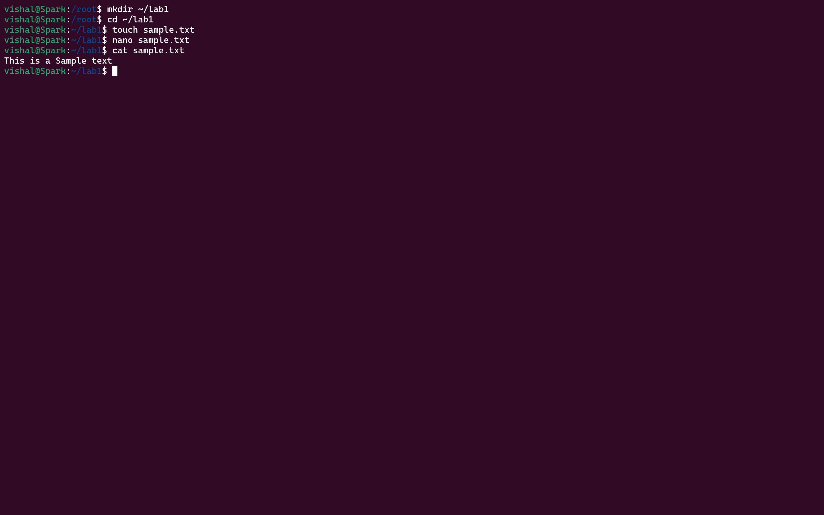

1. **Make a copy of “sample.txt” and name it “sample_copy.txt.”**

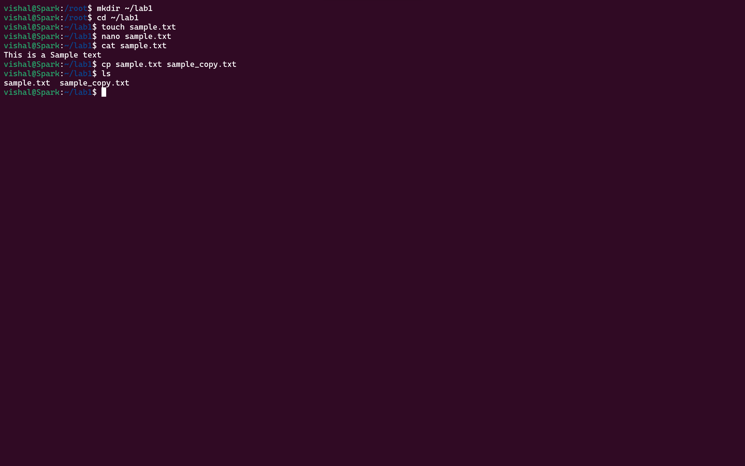

1. **Rename “sample_copy.txt” to “new_sample.txt.”**

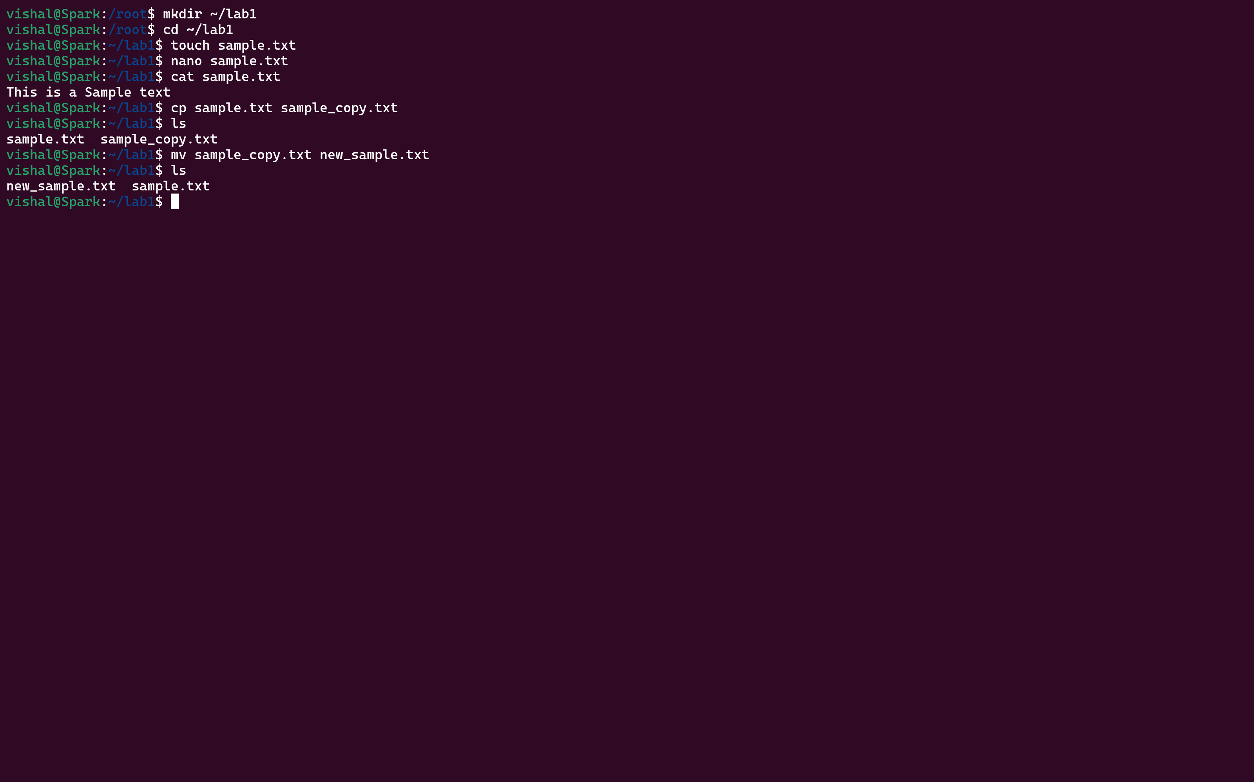

1. **List the files in the “lab1” directory to confirm their names.**



# Lab 2: Permissions and Ownership

1. **Create a new file named “secret.txt” in the “lab2” directory.**

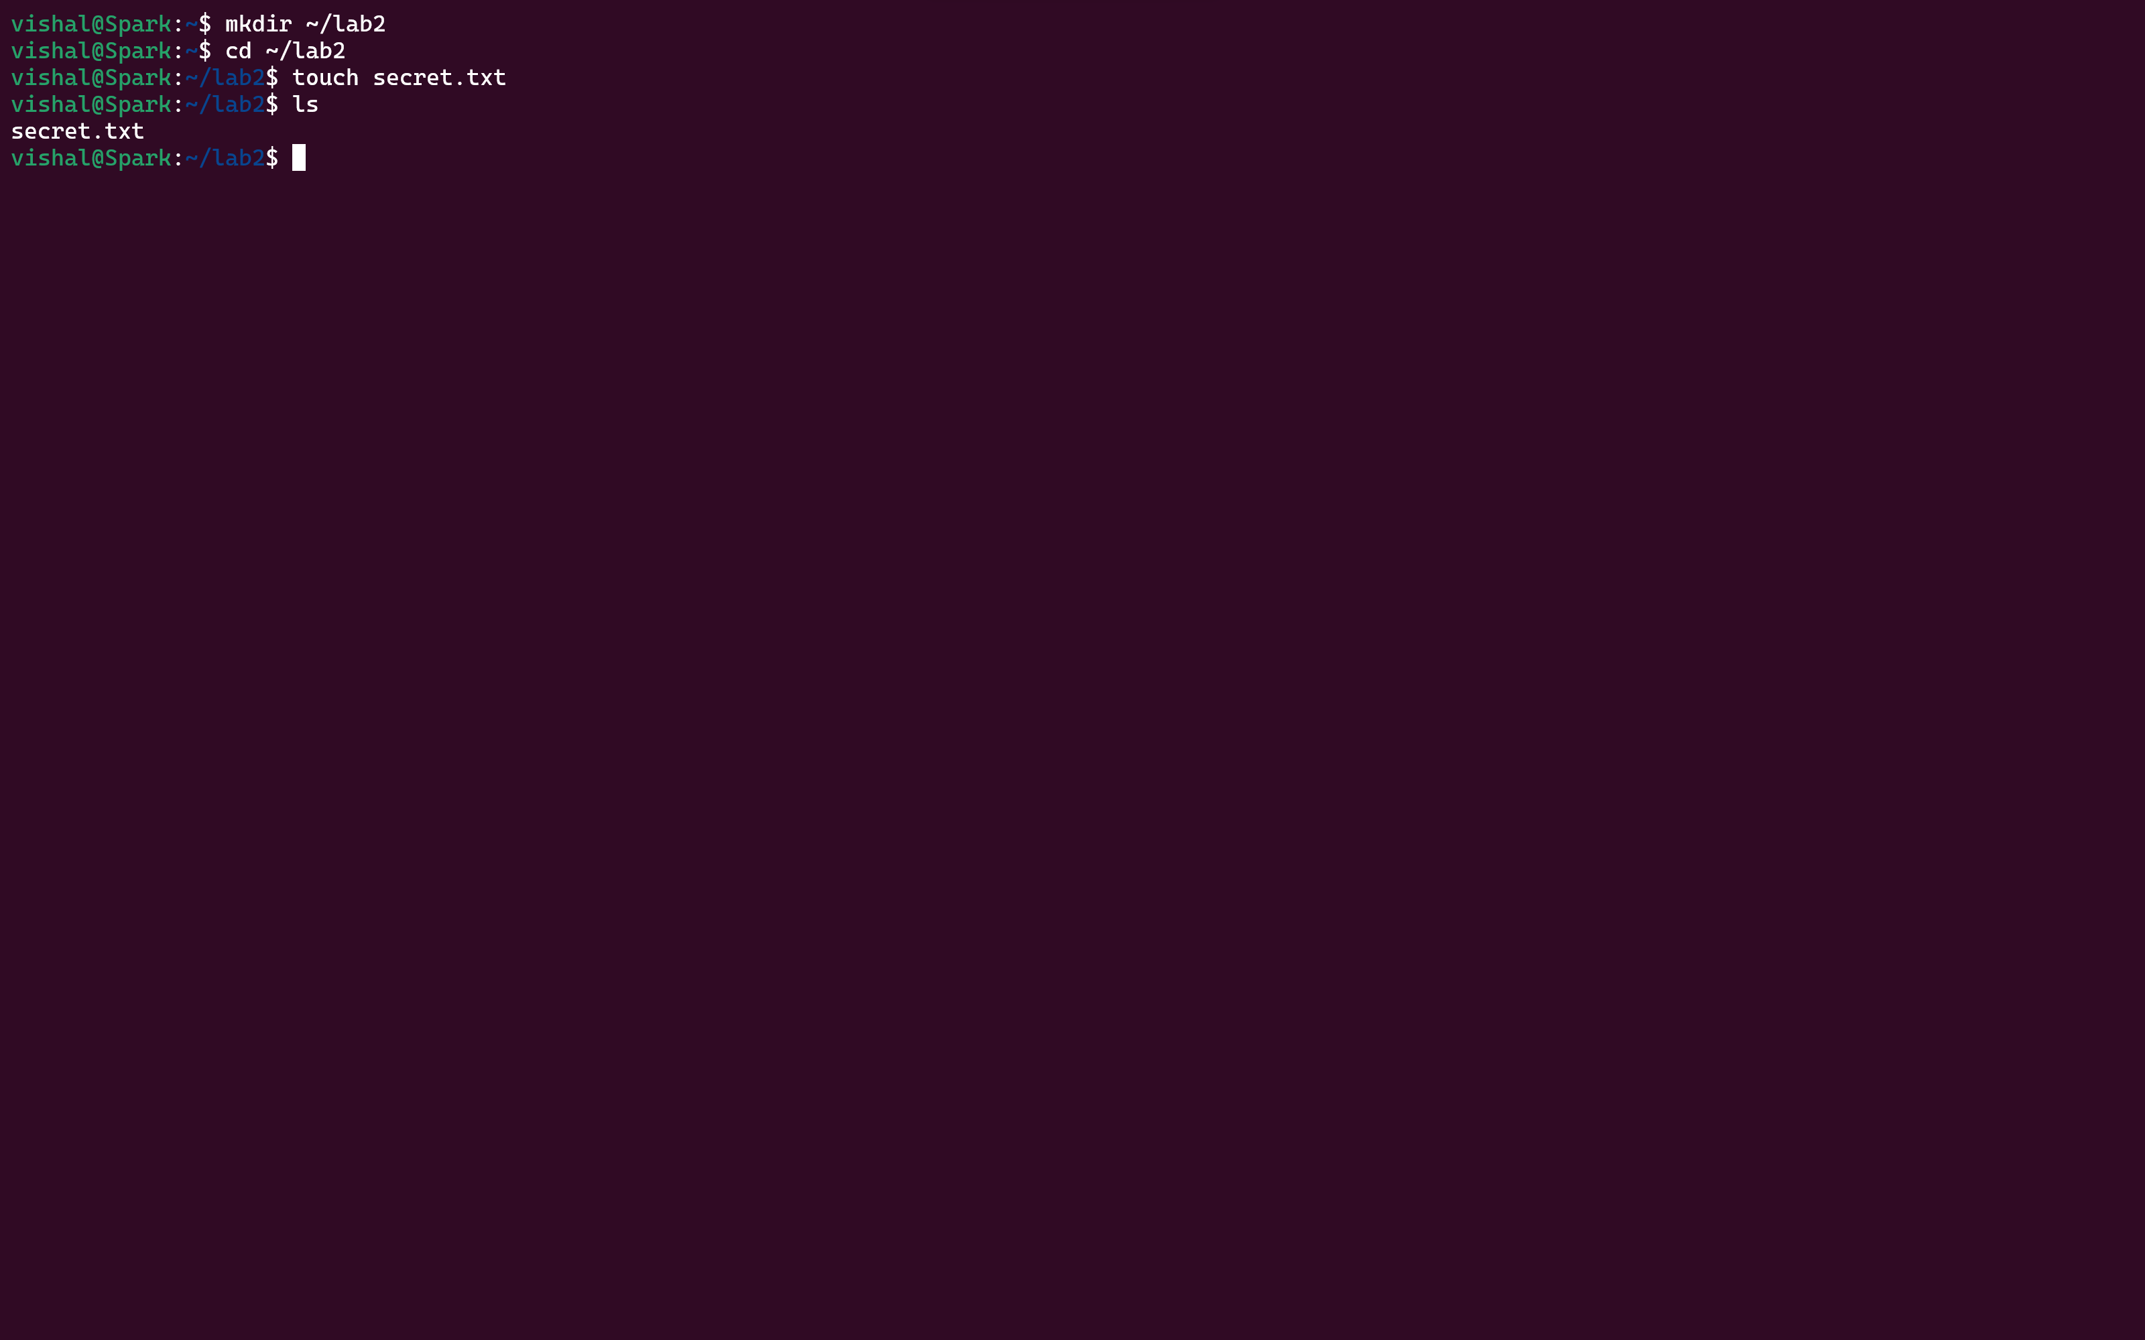

1. **Set the file permissions to allow read and write access only to the owner.**

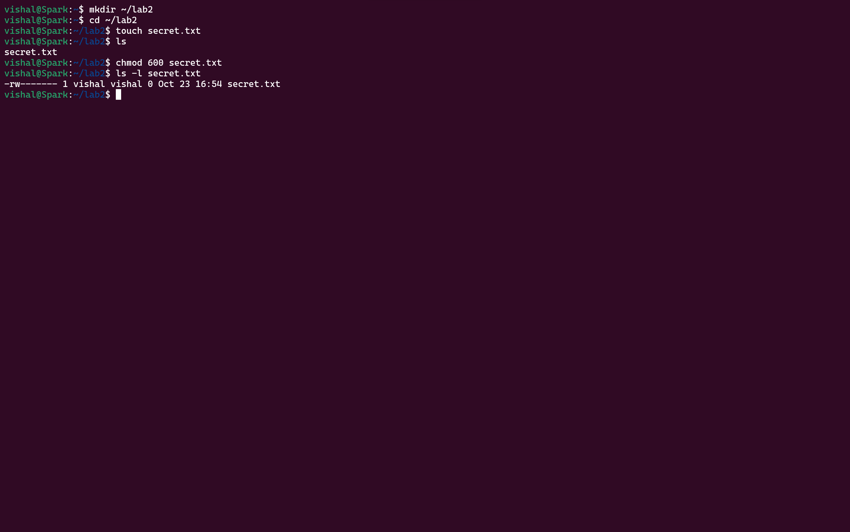

1. **Change the owner of “secret.txt” to another user.**



1. **Verify the new permissions and owner using the ls -l and ls -n**

**commands.**

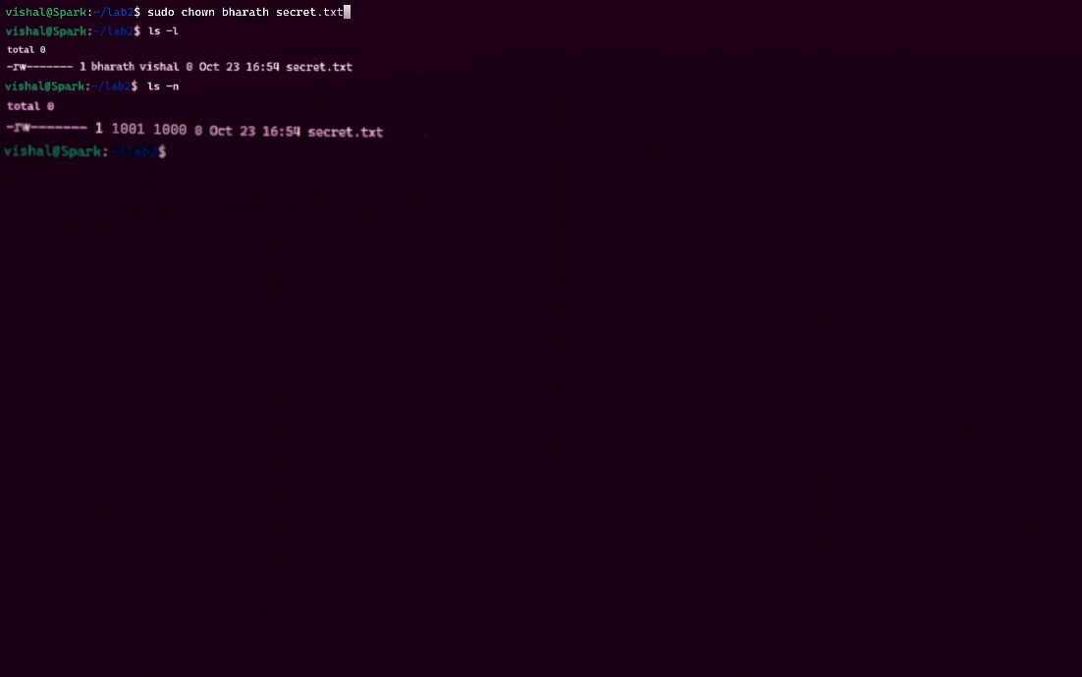

# Lab 3: Text Processing with Command Line Tools

1. **Create a text file with some random text in the “lab3” directory.**

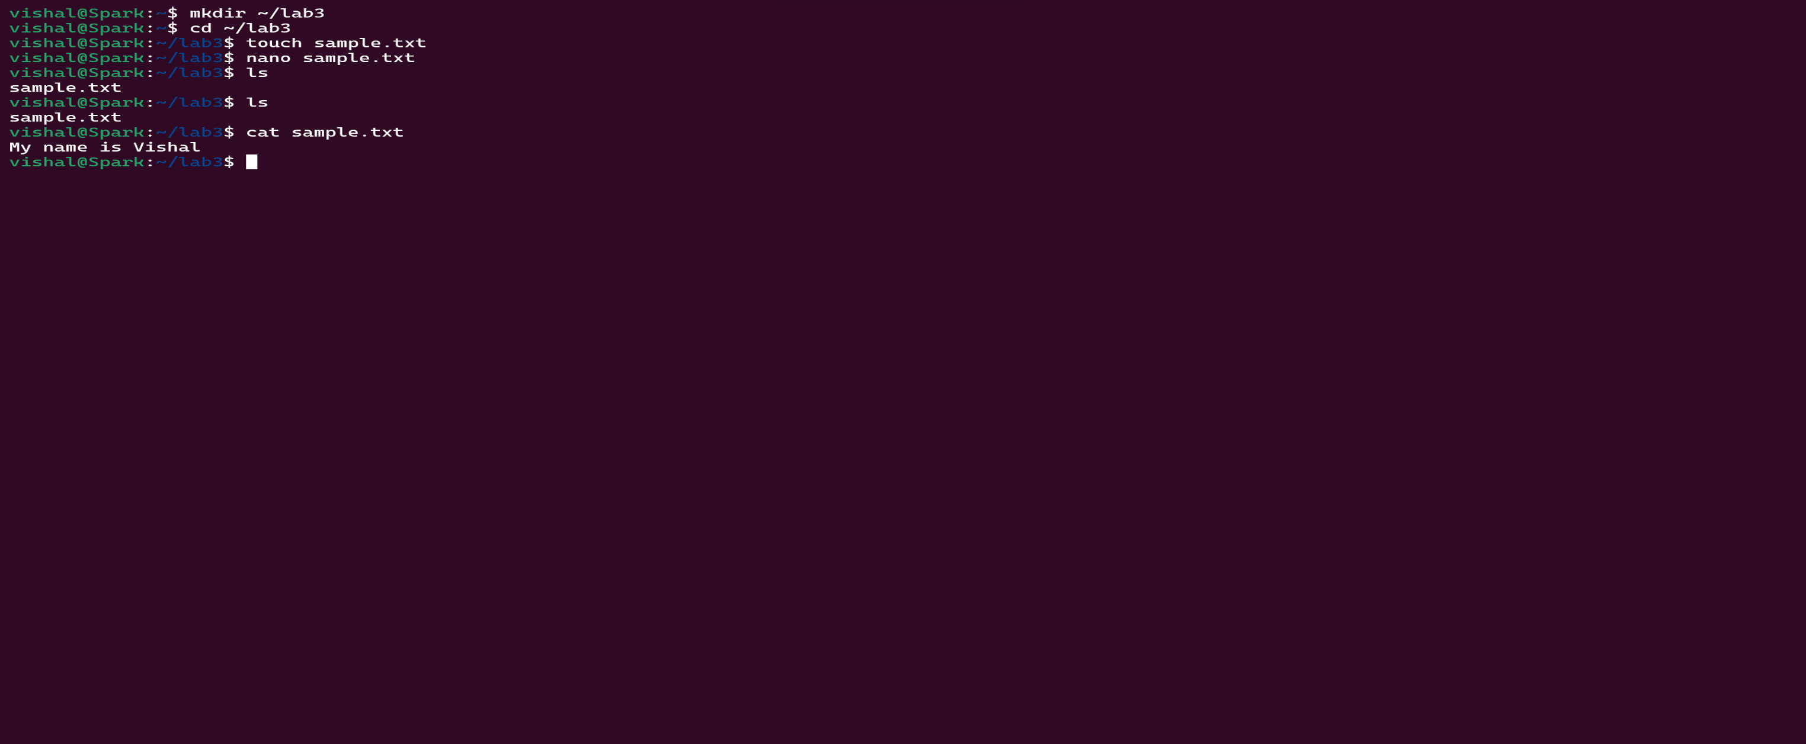

1. **Use the grep command to search for a specific word or pattern in the file.**

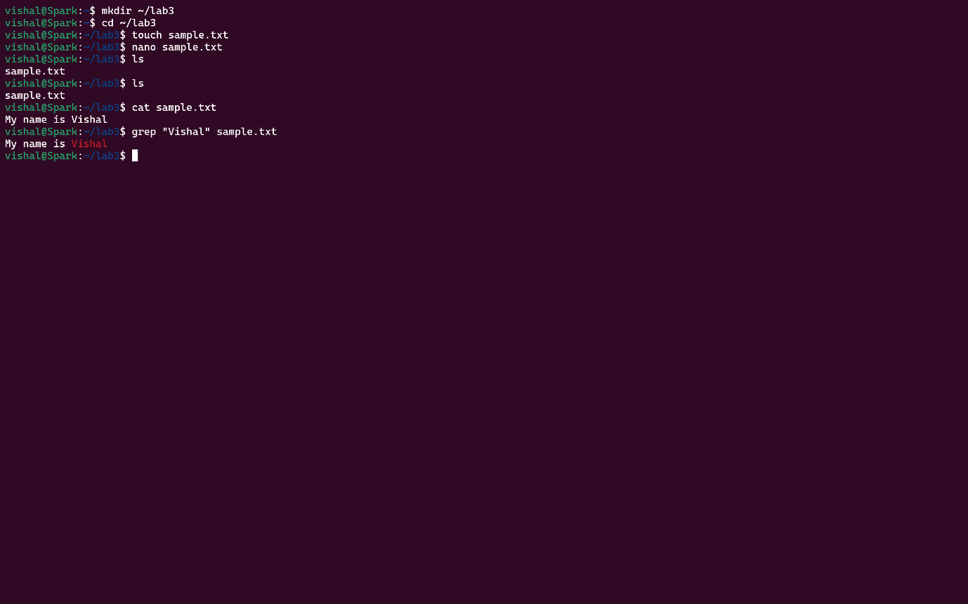

1. **Use the sed command to replace a word or phrase with another in the file.**

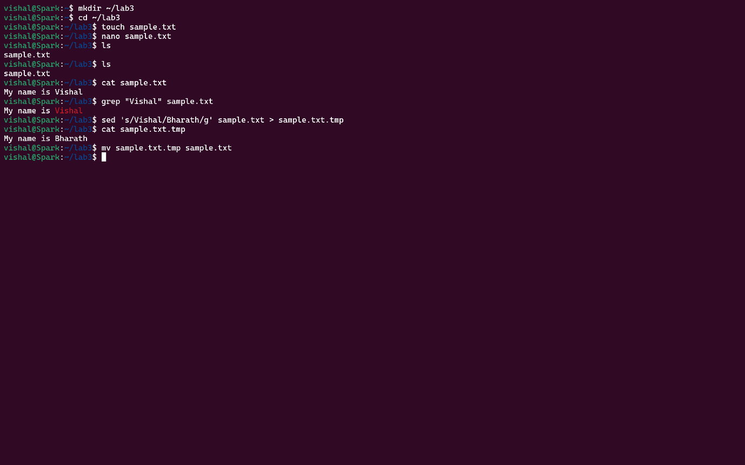

1. **Use the wc command to count the number of lines, words, and**

**characters in the file.**

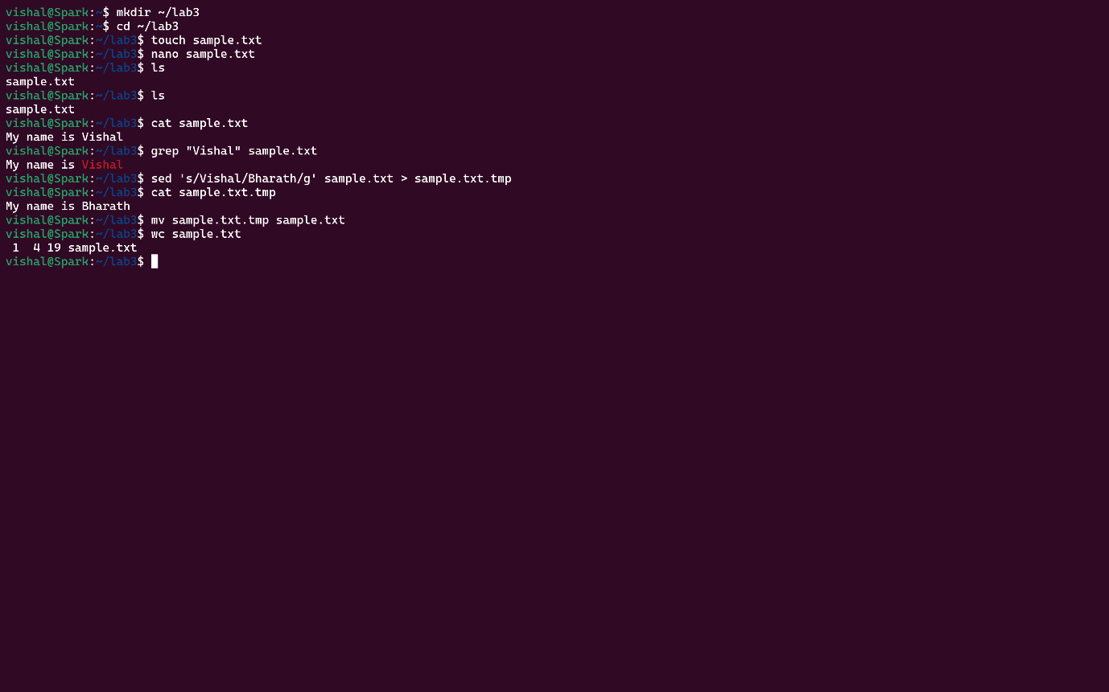

# Lab 4: Creating a Simple YAML File

1. **Create a YAML file named “config.yaml.”**



1. **Define key-value pairs in YAML for a fictitious application, including name, version, and description.**

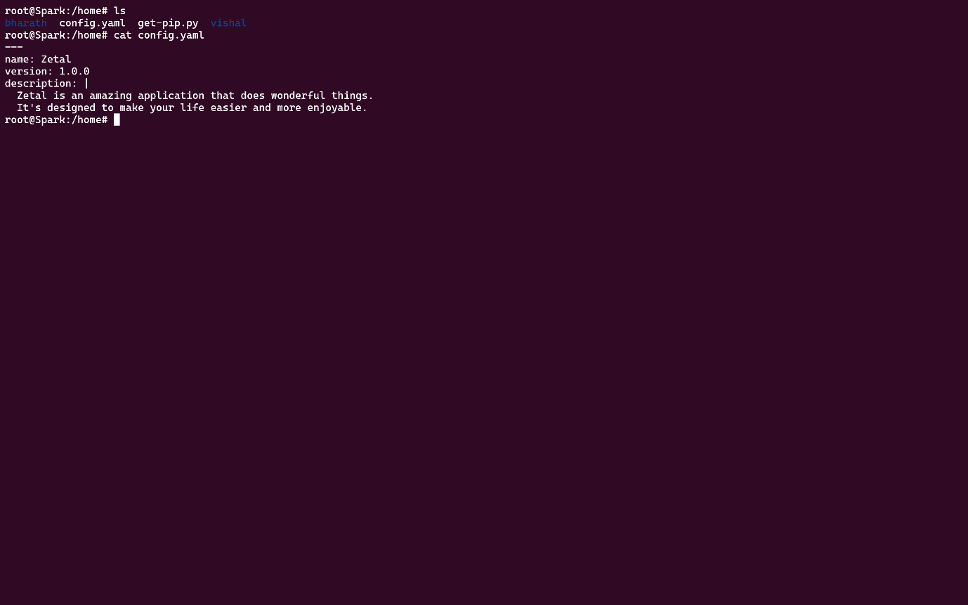

1. **Save the file.**



1. **Validate that the YAML file is correctly formatted.**

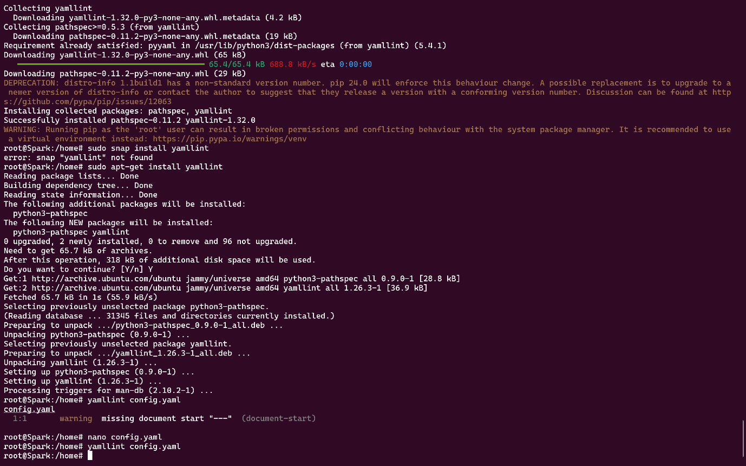

# Lab 5: Working with Lists in YAML

1. **Create a YAML file named “fruits.yaml.”**



1. **Define a list of your favorite fruits using YAML syntax.**



1. **Add items from the list.**

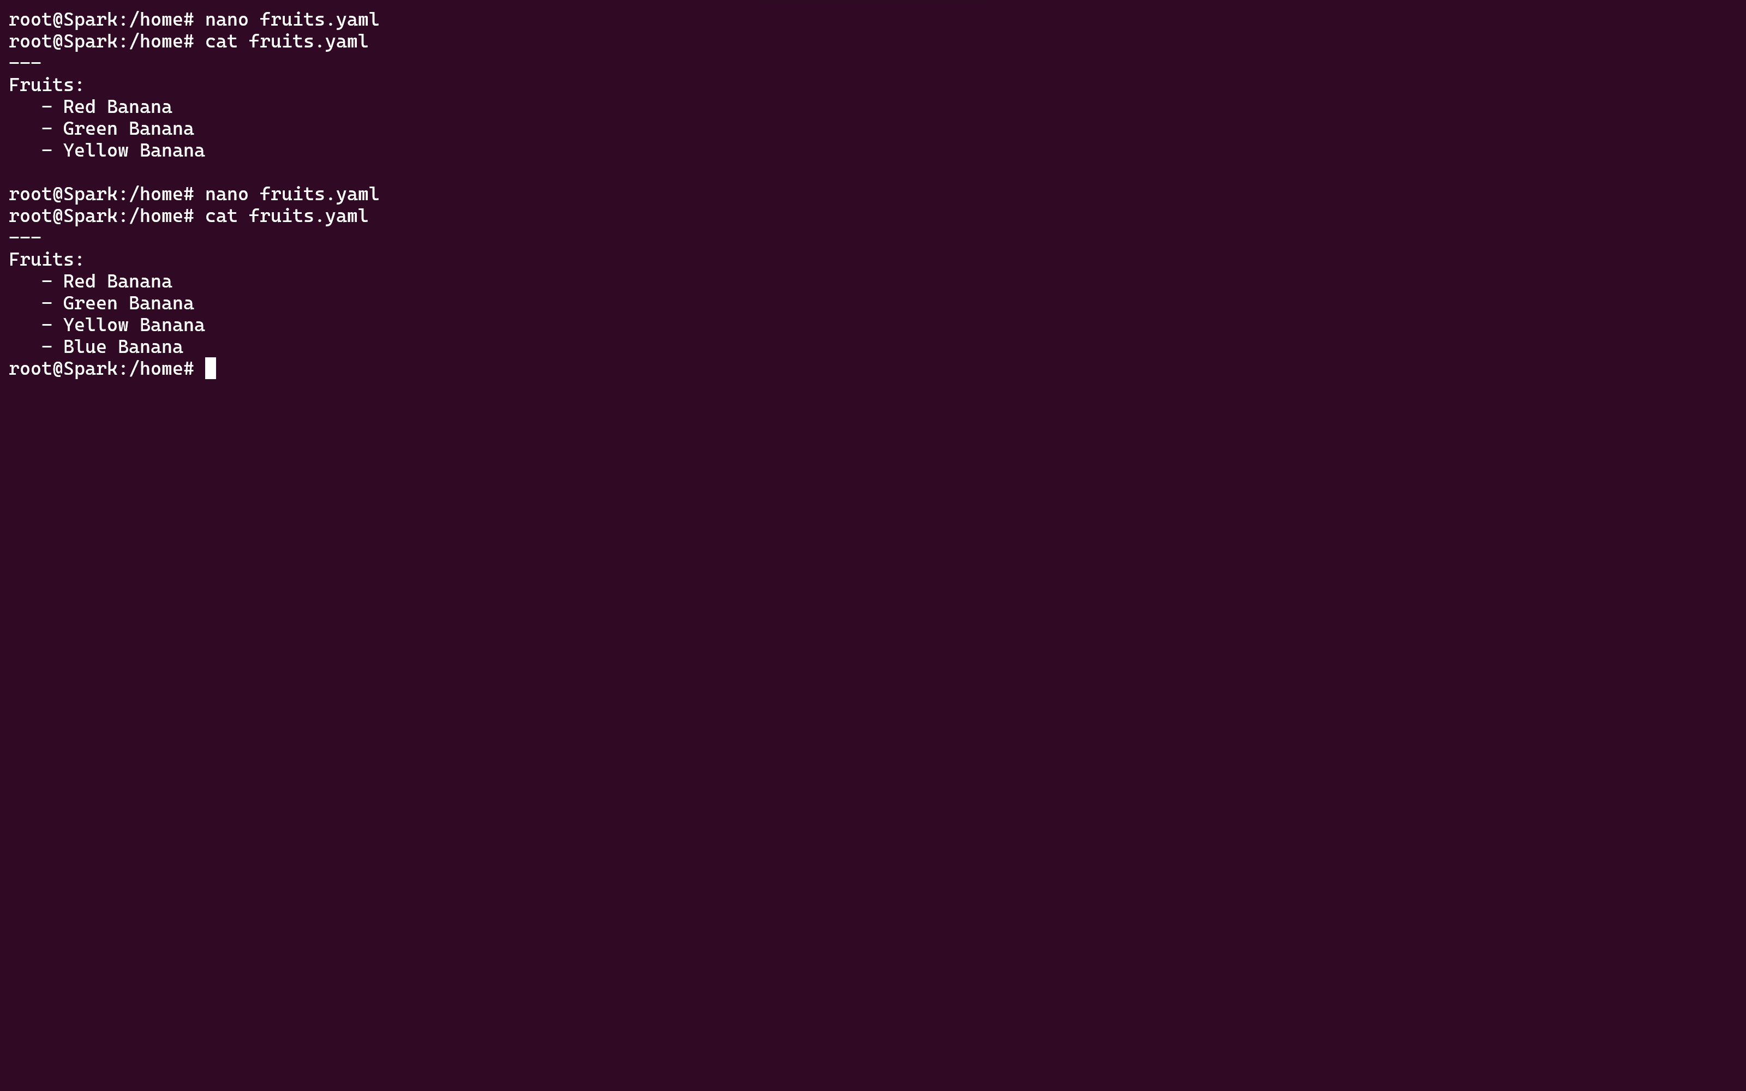

1. **Save and validate the YAML file.**

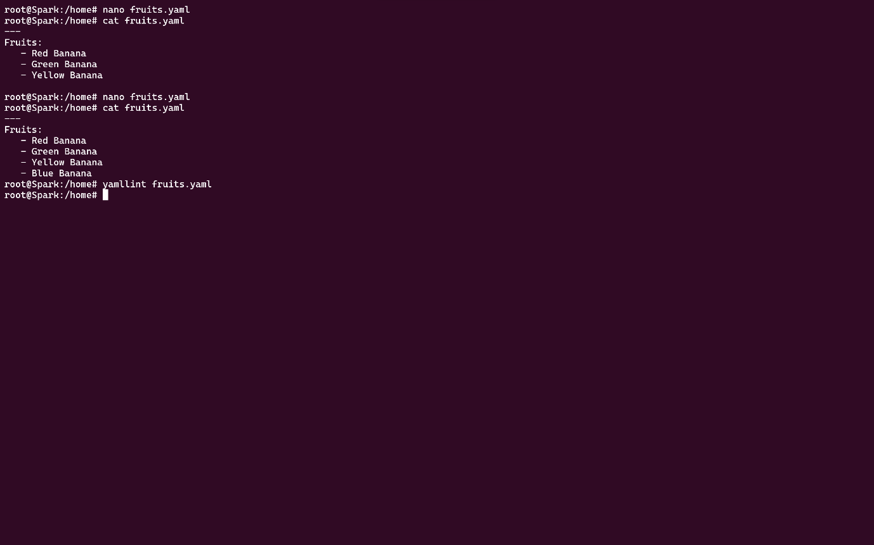

# Lab 6: Nested Structures in YAML

1. **Create a YAML file named “data.yaml.”**



1. **Define a nested structure representing a fictitious organization with departments and employees.**

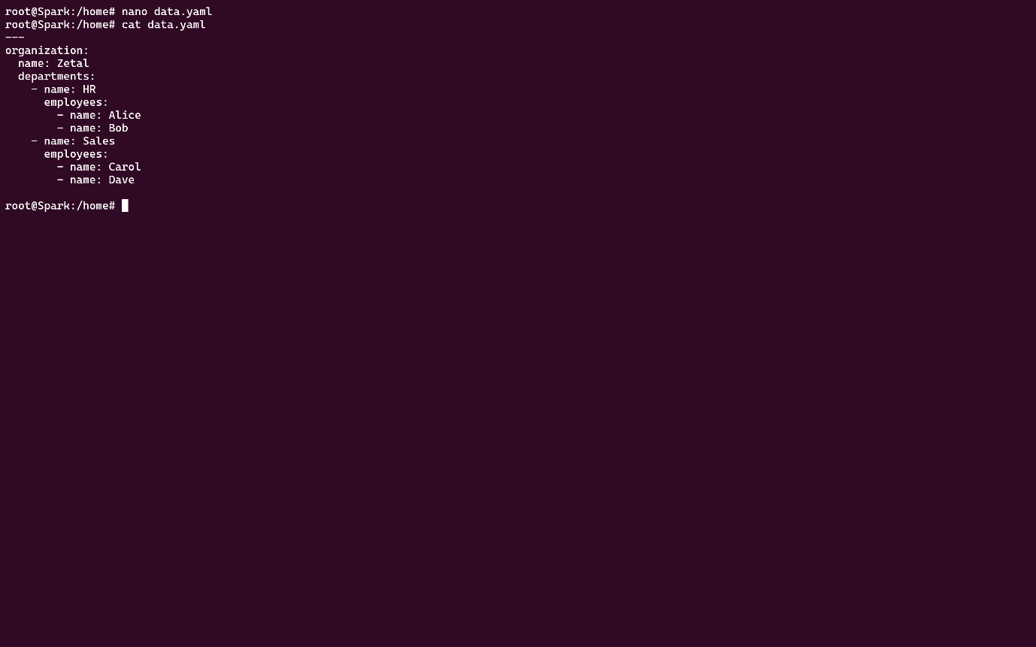

1. **Use YAML syntax to add, update, or remove data within the nested structure.**

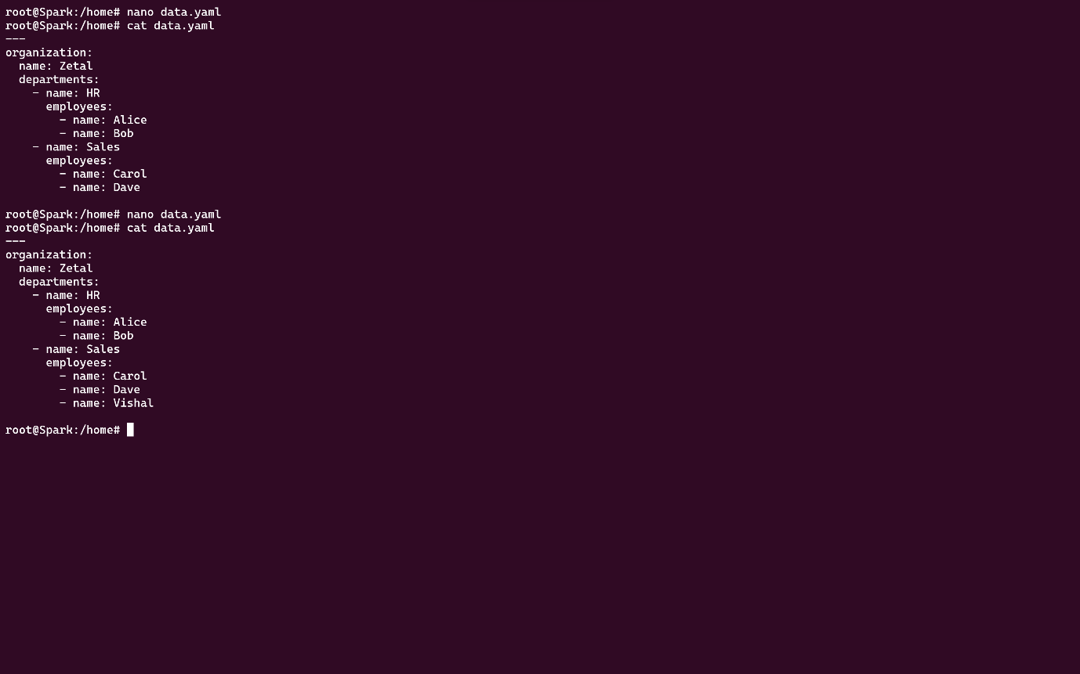

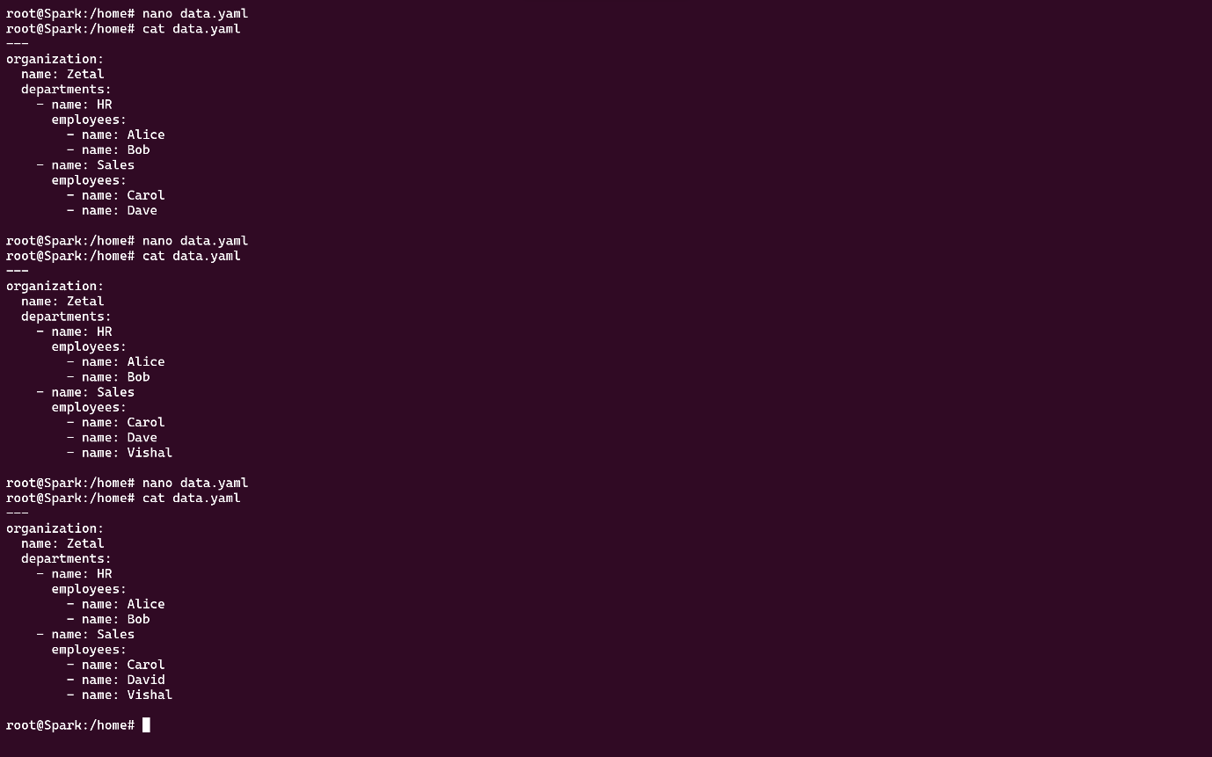

1. **Save and validate the YAML file.**

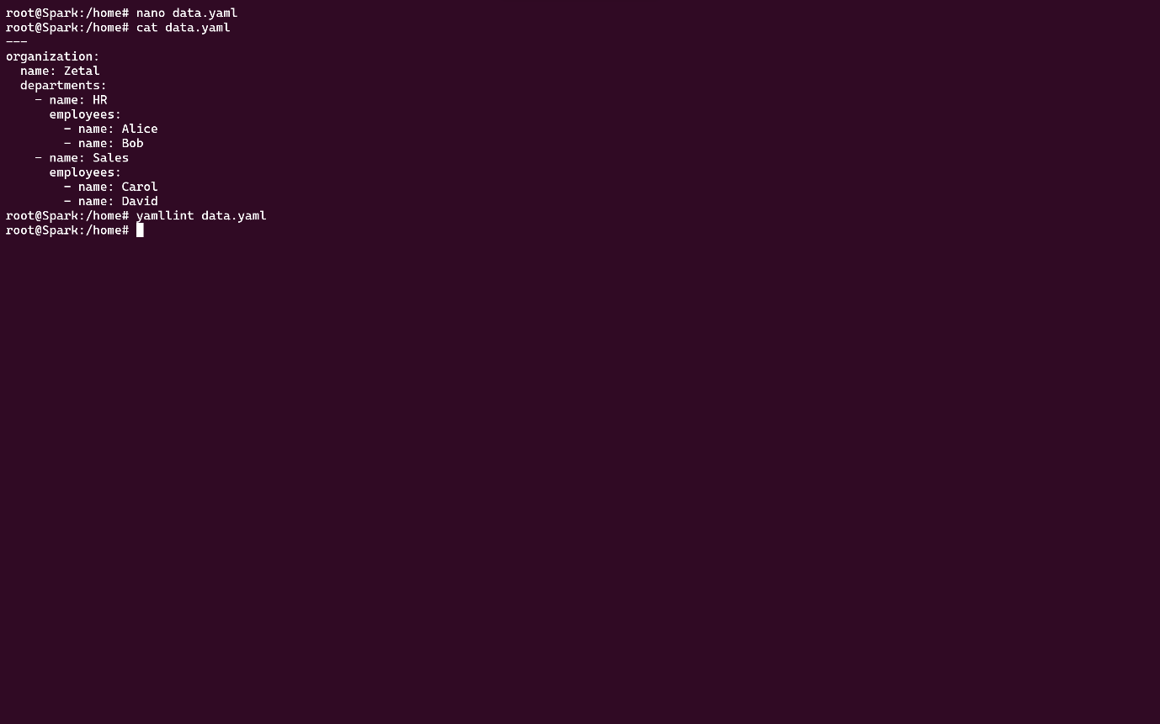

# Lab 7: Create Classic Azure CI Pipeline for Angular Application

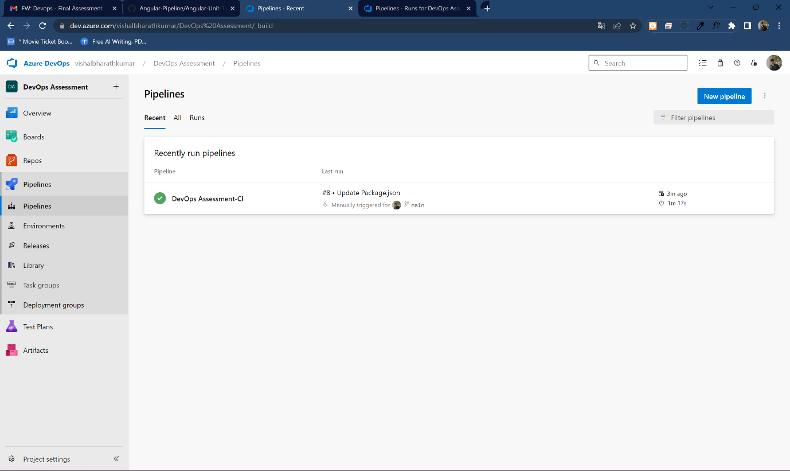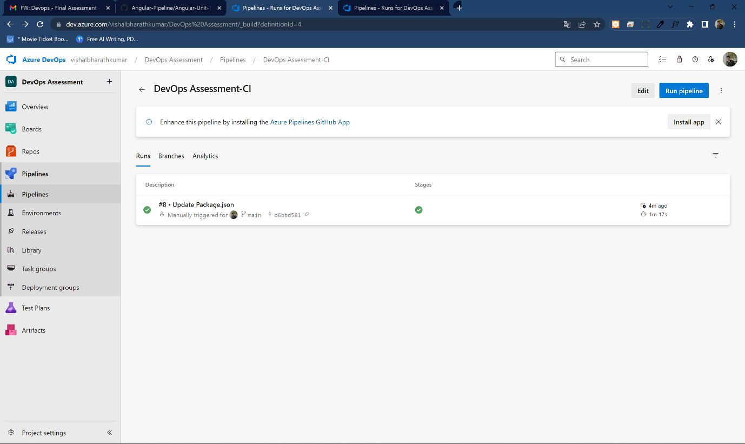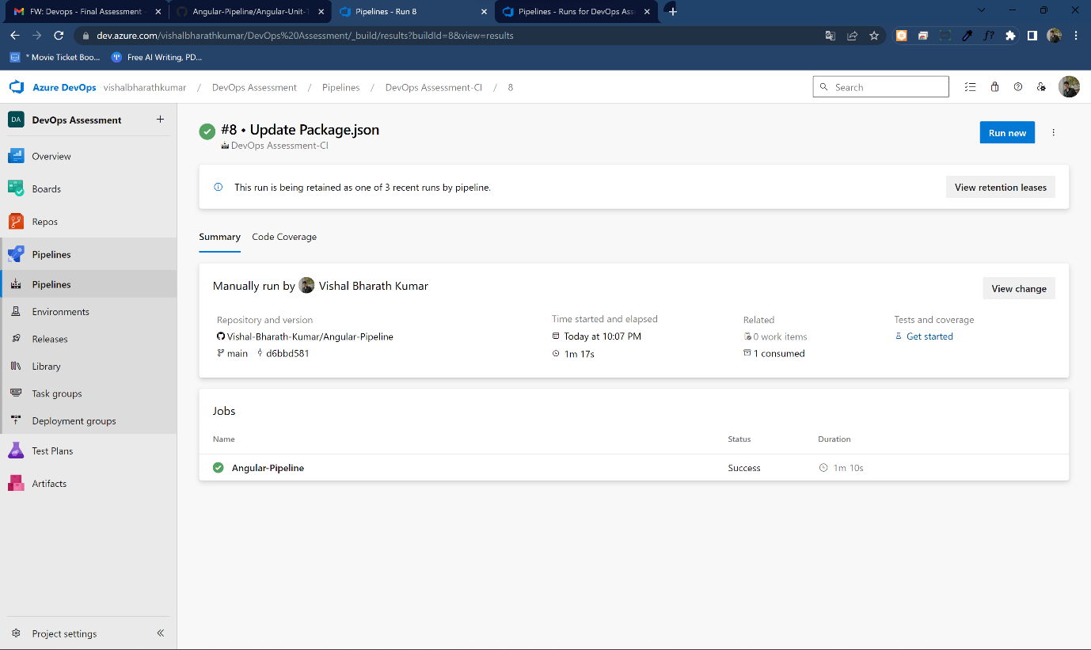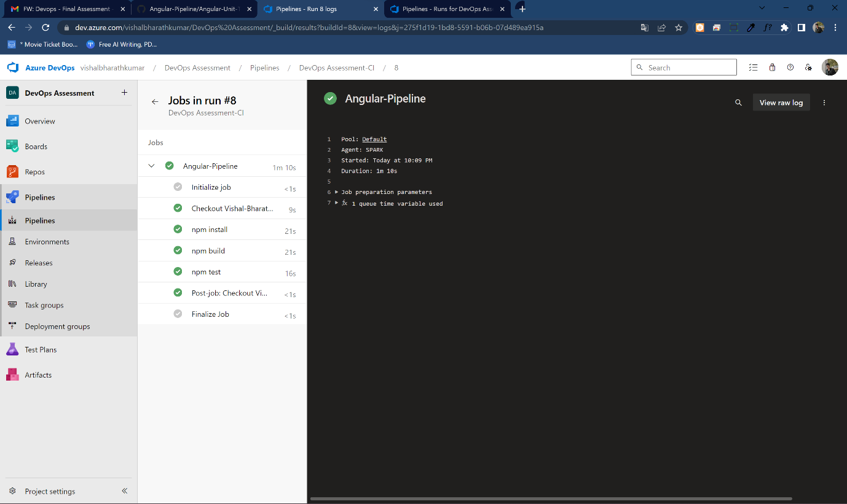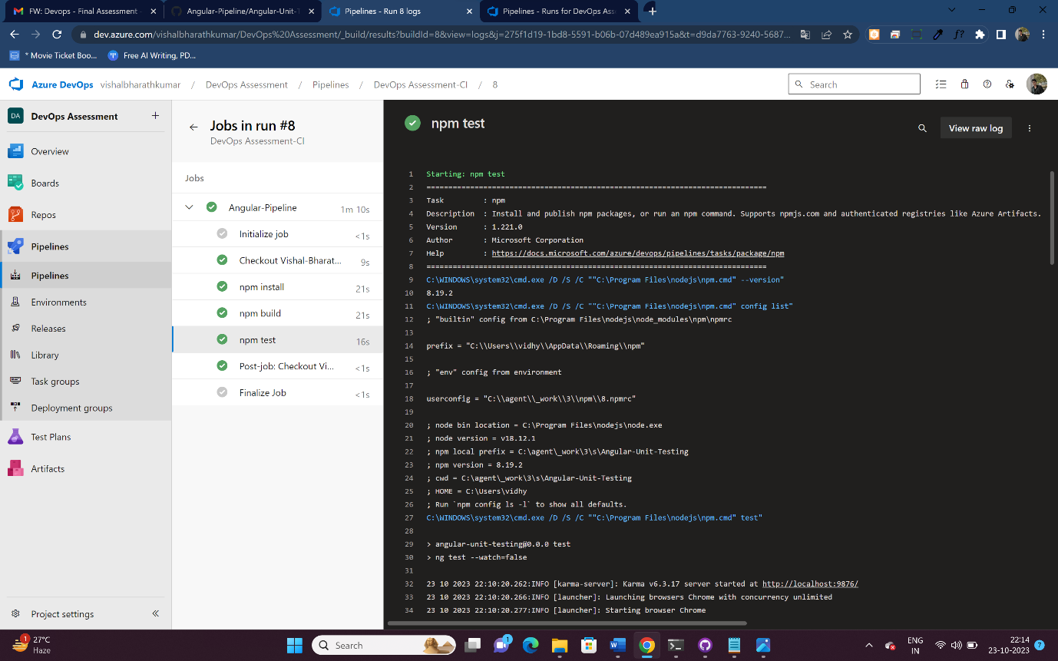

# Lab 8: Create YAML Azure CI Pipeline for React Application

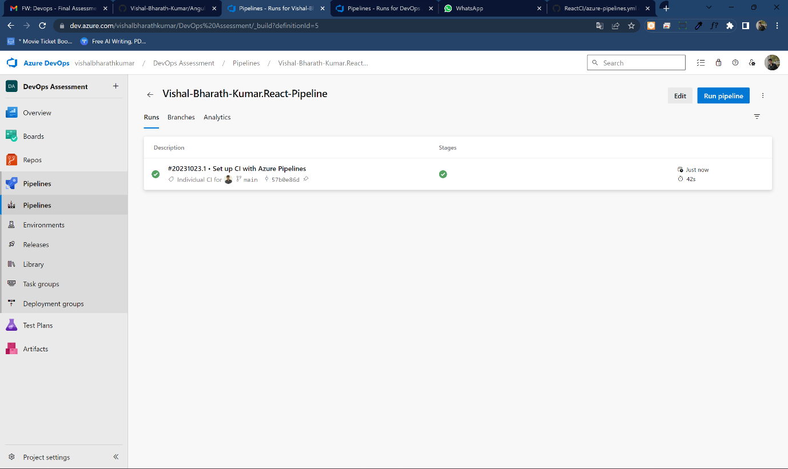

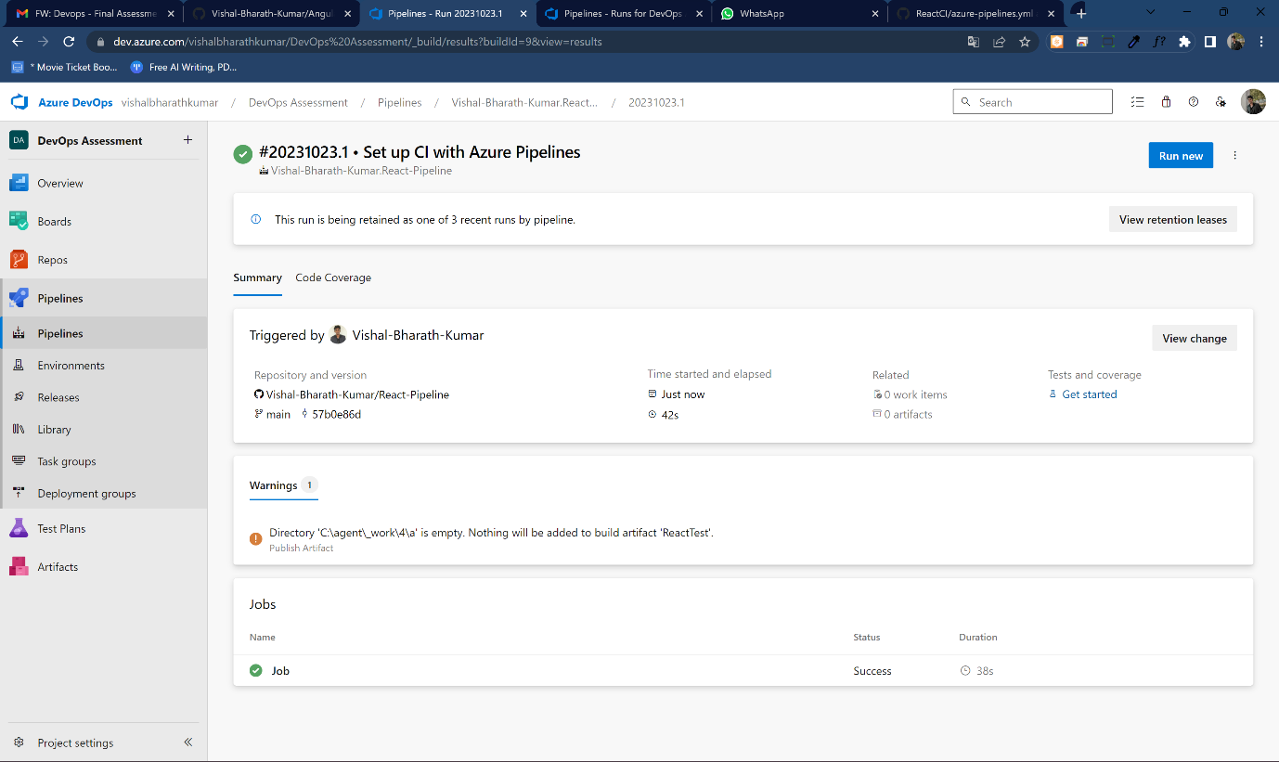

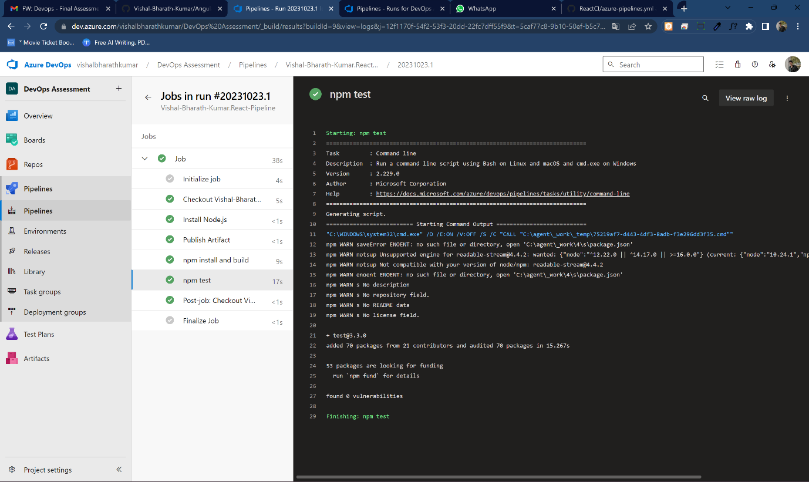

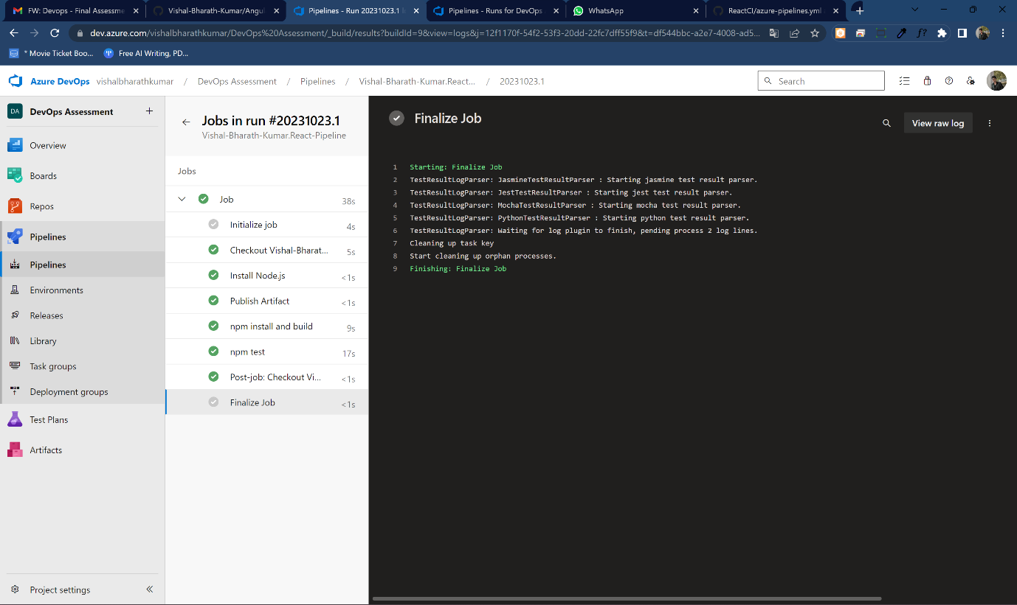

# Lab 9: Create CI Pipeline for .NET Core Application with MS Unit Test

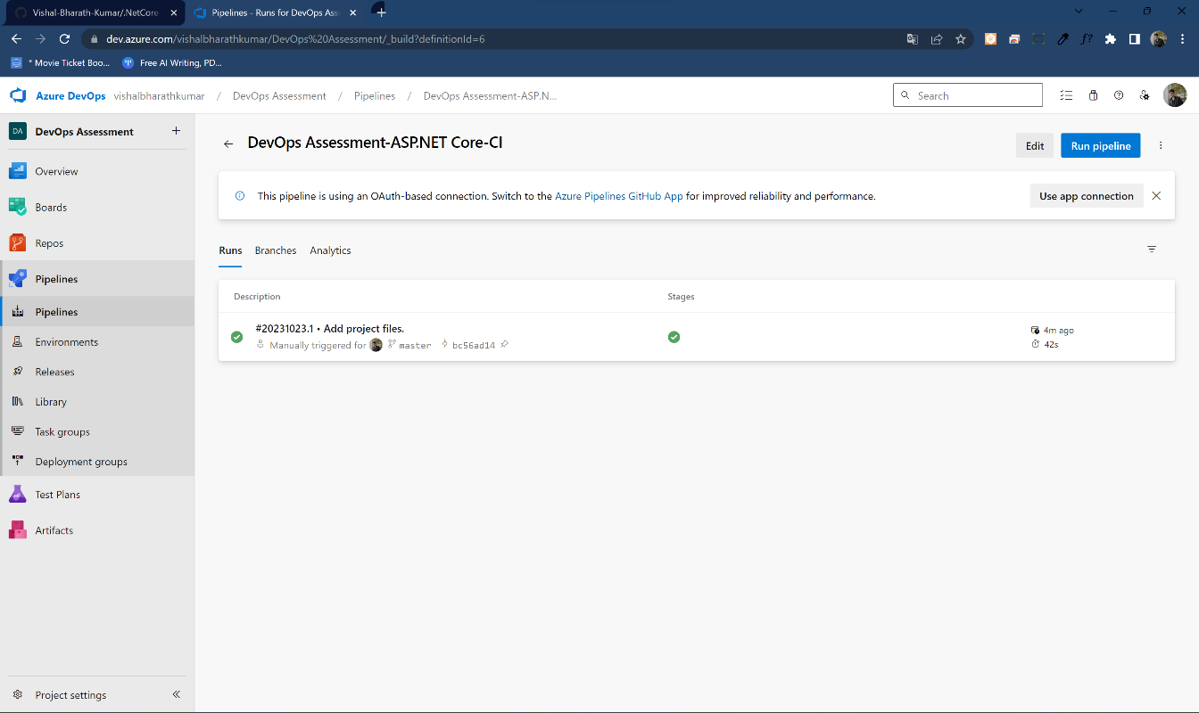

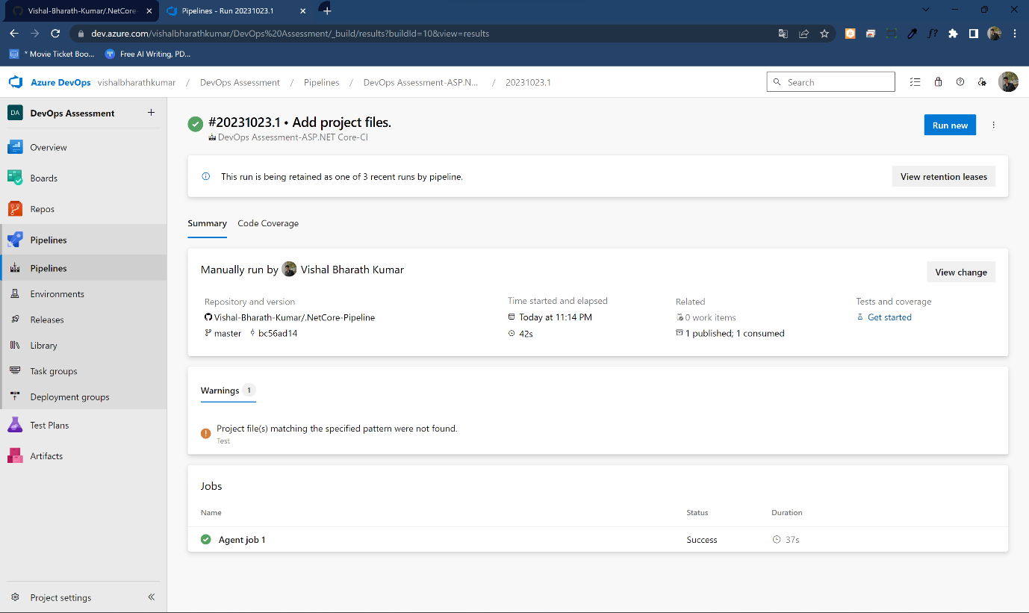

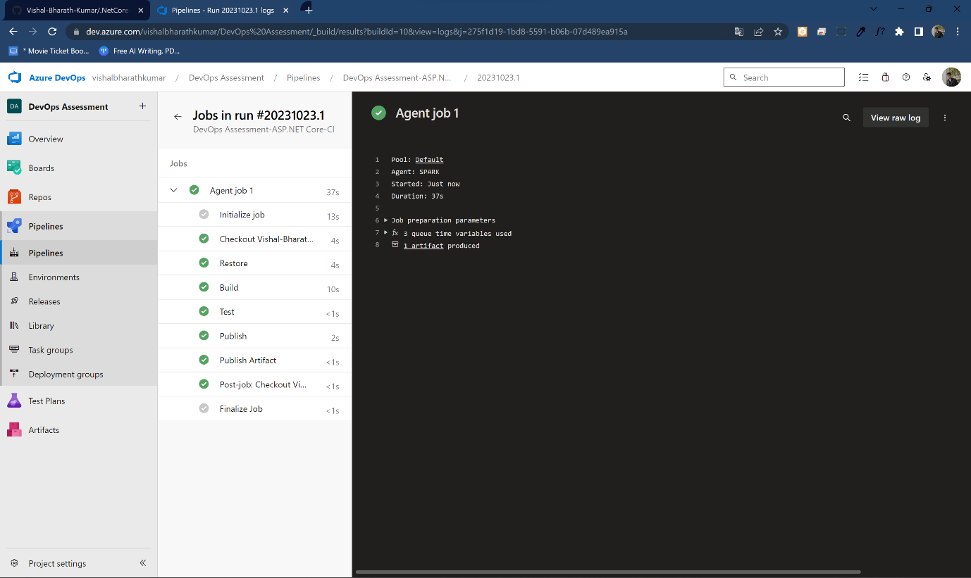

# Lab 10: Creating a Docker Image for a .NET Core Web API and Running it in Rancher Desktop

